Collaborative Practice Agreement:
Physician Referral for Comprehensive Medication Review and Assessment

Introduction:
Asthma is a complex medical condition which often requires close monitoring, medication management, drug dose titration, and patient/caregiver education. The National Heart Lung and Blood Institute (NHLBI), under the guidance of the National Institutes of Health (NIH), has published guidelines directing the care of patients with asthma.¹ These guidelines recommend pharmacists be included as part of the care team to ensure patients achieve asthma control. [Insert Name of Pharmacy] is part of the Wisconsin Pharmacy Quality Collaborative² which is committed to improving health outcomes and reducing health care costs by aligning with evidence-based guidelines. Participating pharmacies and their pharmacists must adhere to a set of quality standards³ designed to increase the quality of pharmacy services provided and maximize patient safety in the medication use process. [Insert Name of Pharmacy] routinely provides Medication Therapy Management (MTM) services and is interested in entering into this CPA.

Purpose
Wisconsin state law allows pharmacists to practice under a Collaborative Practice Agreement with individual physicians (Statute 450.033 Services delegated by physician: A pharmacist may perform any patient care service delegated to the pharmacist by a physician, as defined in s. 448.01(5).
448.01 Definitions. In this chapter: (5) ”Physician” means an individual possessing the degree of doctor of medicine or doctor of osteopathy or an equivalent degree as determined by the medical examining board, and holding a license granted by the medical examining board.
It is the intent of this document to authorize the pharmacists employed by [Insert Name of Pharmacy] to work in a collaborative fashion with and under the direct supervision of the physician(s) listed below. This document establishes a framework and guidelines for collaboration between the physician and pharmacist.

Goals
The goals of this agreement are to:
- Allow pharmacists to conduct a Comprehensive Medication Review and Assessment (CMR/A) session with patients who have asthma that may be sub-optimally controlled (as defined below).
- Improve efficacy of asthma regimen by monitoring adherence, proper device use, and patient response to currently prescribed medications/therapies.
- Enhance patient/caregiver understanding of their prescribed medication regimen.
- Formulate recommendations to optimize therapy, when appropriate.
- Assess and triage potential and significant adverse drug reactions to the physician(s) named in this agreement.
- Increase collaboration between [Insert Name of Pharmacy] and the physicians named below.

Policy:
Patients who may have sub-optimally controlled asthma as defined by the statements immediately below may be evaluated by the pharmacist for an initial CMR/A. Patients who have received an initial CMR/A are automatically eligible to receive follow-up visits, if necessary.
- Refills of short-acting beta-agonist (SABA) exceeding 2 canisters(200 puffs per canister) in 90 days.
- Refills of monthly asthma controller medications less than 3 times in the past six months
- Asthma Control Test™ or Childhood Asthma Control Test™ score of <19. [See Appendix 1]
- Classification of “Not Well Controlled” or “Very Poorly Controlled” as defined by the NIH Guidelines for Asthma Control Assessment and Therapy. [See Appendix 2]
- Recent (within 14 days) discharge from the hospital or emergency department due to an asthma exacerbation.

The CMR/A consists of a face-to-face visit with the patient (and/or the patient’s caregiver) to:
- Assess/review prescription and over-the-counter medications
- Review and promote medication adherence
- Review medication device usage and provide reinstruction if needed
- Identify potential drug therapy problems
- Explore more cost effective medication regimens
- Monitor medication efficacy
At the conclusion of each visit, the patient receives a Medication Action Plan and an updated Personal Medication List. The physician receives this visit summary, an updated list of all the medications/OTCs the patient is taking, as well as a listing of the patient’s refills of asthma controller and reliever medications in the past 12 months. This communication may or may not include recommendations for change. Pharmacists are not allowed to make any changes to the patient’s medication regimen without health care prescriber approval. Pharmacists strongly encourage patients to see their physician for follow-up care or when concerns arise. The care provided by the pharmacist is designed to complement, not replace, the usual and standard care provided by the patient’s physician.

This agreement is voluntary and may be terminated via written request at any time by either party. This document will be reviewed by both parties at least [annually or insert other time frame here].

Signatures of participating physicians:
This agreement is effective date as of the dates set forth below:
Physician Name: _________________________________________ State License Number: _____________________
Physician Signature: ______________________________________ Date Signed: _____________________________

Physician Name: _________________________________________ State License Number: _____________________
Physician Signature: ______________________________________ Date Signed: _____________________________

Physician Name: _________________________________________ State License Number: _____________________
Physician Signature: ______________________________________ Date Signed: _____________________________

Physician Name: _________________________________________ State License Number: _____________________
Physician Signature: ______________________________________ Date Signed: _____________________________
References:
- EPR. Expert panel report 3: Guidelines for the diagnosis and management of asthma (EPR 2007). NIH Publication Number 08-5846. Bethesda, MD: U.S. Department of Health and Human Services; National Institutes of Health; National Heart, Lung, and Blood Institute; National Asthma Education and Prevention Program, 2007.
- The Pharmacy Society of Wisconsin. Welcome to WPQC. Available at www.pswi.org/wpqc, Accessed February 9, 2015.
- Wisconsin Pharmacy Quality Collaborative (WPQC) Medication Therapy Management (MTM) Services Program. 23 April 2014. Available at http://www.pswi.org/Portals/17/WPQC/Wisconsin%20Pharmacy%20Quality%20Collaborative%20Medication%20Therapy%20Management%20Services%20Program.pdf, Accessed February 9, 2015.

Appendix 1:
Adult Asthma Control Test:
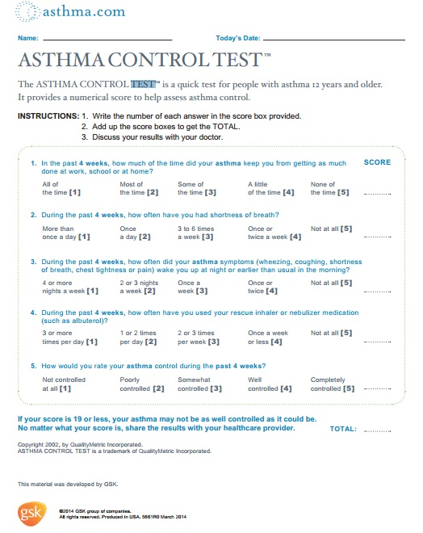

Childhood Asthma Control Test:
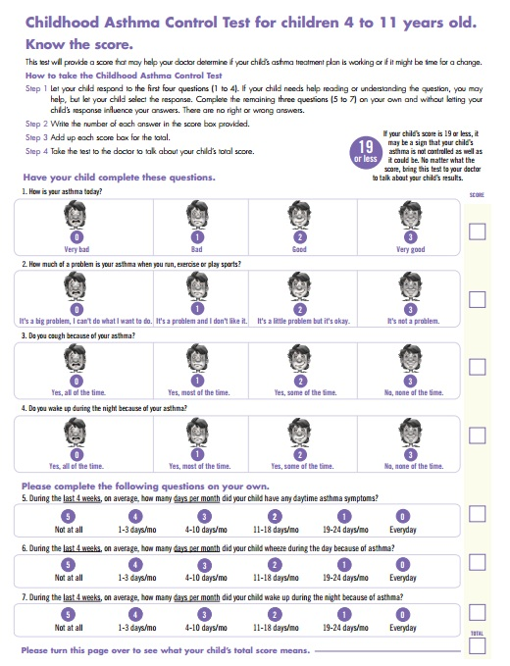

Appendix 2:

Assessing Asthma Control and Adjusting Therapy in Youths >12 Years of Age and Adults¹
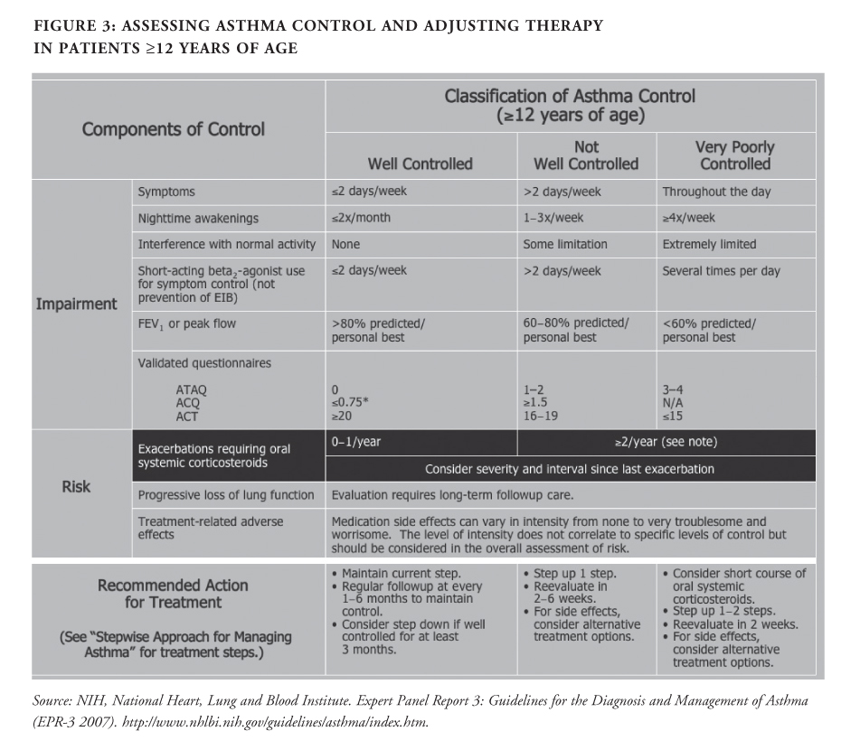

Assessing Asthma Control and Adjusting Therapy in Children¹

